**FORM 317**

*(See* rule 24 )

***Order of cancellation of assessment order under sub-section (11) of section 23 of the Maharashtra Value Added Tax Act, 2002***

To

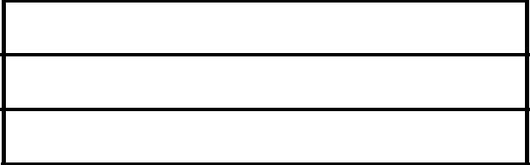

M/s

No.: Dated:

(1) Name of the Dealer

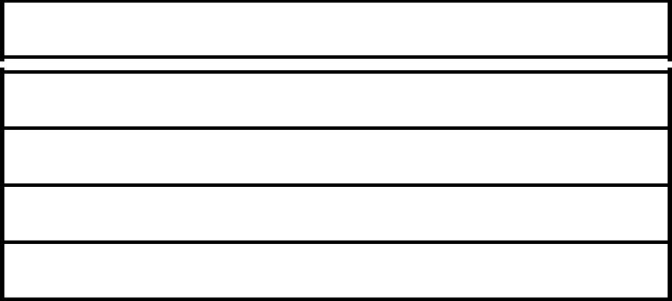

1. Address of the place of Business



(3) R.C. No. /TIN M.V.A.T. Act, 2002



(4) R.C. No. /TIN under CST Act, 1956.

With reference to your application in Form -316 dated _________ the assessment order for the period from _______________ to ____________________

is hereby cancelled.

|  |  |  |  |
| --- | --- | --- | --- |
| Date |  |  |  |
|  |  |  | Signature and Stamp of Assessing |
| Place |  |  | Authority |

**FORM 317**

*(See* rule ____)

***Original***

***Order of cancellation of assessment order under sub-section (11) of section 23 of the Maharashtra Value Added Tax Act, 2002***

To



No.: Dated:

(1) Name of the Dealer



1. Address of the place of Business



(3) TIN M.V.A.T. Act, 2002



(4) TIN under CST Act, 1956.

With reference to your application in Form -316 dated _________ the assessment order for the period from _______________ to ____________________

is hereby cancelled.

|  |  |  |
| --- | --- | --- |
| Date |  |  |
|  |  | Signature and Stamp of Assessing |
| Place |  | Authority |

